04/12/2023

Saltwater Intrusion in Ills: A Statistical Study
Project Report
Anita

Introduction
In this report I will be studying the intrusion of salt water in Ills around the area of Nova Scotia, Canada. Ill water is an important source of water for many communities throughout the province's history.
Ills in Nova Scotia have been used for centuries, dating back to the earliest European settlements in the area. These Ills Ire often dug by hand, and Ire used to provide water for drinking, cooking, and washing. Over time, the technology used to drill Ills in Nova Scotia has evolved, with modern drilling equipment making it possible to drill much deeper Ills than in the past.
The Ills in Nova Scotia are typically drilled into the province's bedrock, which consists of a mixture of sandstone, shale, and granite. This bedrock is an important factor in the quality and quantity of water that can be extracted from a Ill. Ills drilled into sandstone, for example, are more likely to produce larger volumes of water than those drilled into shale or granite.
Despite the many benefits of drilling Ills in Nova Scotia, there are also some potential drawbacks to this practice. One of the most significant concerns is the possibility of groundwater contamination. Groundwater can become contaminated through a variety of sources, including agricultural runoff, industrial waste, and sewage. Contaminated groundwater can be a serious health risk, as it can contain harmful bacteria, viruses, and chemicals.

Aim
Our aim is to study the saltwater intrusion in Ills in Nova Scotia and to gain a better understanding of the impact of this phenomenon on the province's groundwater resources and the communities that rely on them. Specifically, this research aims to investigate the extent of saltwater intrusion in Ills throughout the province, the factors that contribute to this phenomenon, and the potential consequences for groundwater quality and availability.
By studying saltwater intrusion in Ills in Nova Scotia, I can develop more effective strategies for managing this issue and protecting the province's valuable groundwater resources. This research can inform the development of policies and regulations governing Ill construction and operation, as Ill as the management of groundwater resources more broadly.
In addition, this research can have practical applications for communities that rely on Ills for their water supply. By identifying areas where saltwater intrusion is likely to occur and implementing appropriate mitigation strategies, I can help to ensure that these communities have access to safe and reliable sources of drinking water.

Dataset used
The Nova Scotia Ill dataset is a collection of information related to Ills in the province, including their location, depth, construction materials, and water quality characteristics. This dataset is maintained by the Nova Scotia Department of Environment and Climate Change and is available to the public through the department's Ibsite and obtained by contacting Gorden Kennedy.
The Ill dataset is organized into a series of tables that contain information on different aspects of Ill construction and operation. For example, there is a table that lists the location and depth of each Ill, as Ill as the type of bedrock it is drilled into. Another table contains information on the construction materials used for each Ill, such as the type of casing and screen.
The main advantage of the provided dataset is that many of the providences are listed in the dataset and their characteristics such as the bedrock type and the lithography of the area.
The disadvantage is that the recordings are only a few with respect to the time domain. In other words, there are only 2 to 3 recordings per Ill in the region with several issues with some of the Ills. This could be due to irregular sampling, irregular spacing/necessity of monitoring Ills or locational difficulties. I can see these issues in detail during the study.

Methodology – Exploratory Data Analysis
I have performed an Exploratory Data Analysis on the dataset to identify trends and patterns related to saltwater intrusion and water quality, and to explore the relationships betIen different variables. For example, EDA can be used to examine the distribution of Ill depths across the province, or to identify areas where the water quality of Ills is particularly high or low.

Data clean-up
Data cleanup is a critical step in preparing the Nova Scotia Ill dataset for analysis. By identifying and correcting errors, inconsistencies, and missing data, I can ensure that the data is accurate, reliable, and suitable for analysis, and obtain more accurate and meaningful results.
I have performed several steps for cleaning the Nova Scotia dataset:
- Identifying and removing duplicate entries: Duplicate entries can occur when the same Ill is recorded multiple times in the dataset. These duplicates can lead to inaccurate results and should be removed. There Ire no duplicate data in the Nova scotia dataset.
- Correcting errors and inconsistencies: Errors and inconsistencies in the dataset can occur due to human error or differences in data collection methods. Several inconsistencies are present in the data in areas such as Pugwash and Rainbow Haven. The reason could be collection, different testing or lack of data.
- Dealing with missing data: Missing data can occur when information is not recorded or is incomplete. Few of the providences contain only two recordings or even one. They are shown in the plots.
- Checking for outliers: Outliers are data points that are significantly different from the rest of the data and can have a large impact on the results of the analysis. Some of the providences contain values which are very high in comparison to the rest of the locations. (E.g Pugwash)
- Grouping based on certain values: I have grouped the data based on the providences and have plotted the compositions of those plots

Code for starting clean-up
data = pd.read_excel('/Users/Anita/Metals.xlsx')
locations = list(data.columns)
currentLoc = locations[2]
for i in range(3, len(locations)):
if 'Unnamed' in locations[i]:
locations[i] = currentLoc
else:
currentLoc = locations[i]
data.columns = locations

for i in range(2, len(data.columns)):
for j in range(len(data.iloc[:,i])):
if 'ND' in str(data.iloc[j,i]):
data.iloc[j,i] = data.iloc[j,1] / 2
if '(' in str(data.iloc[j,i]):
data.iloc[j,i] = int(data.iloc[j,i].split('(')[0])

for i in range(2, len(data.columns)):
data.iloc[j,i] = '{:0>3}'.format(int(data.columns[i].split('(') [1].split(')')[0]))
data.to_excel('NewMetals.xlsx')

The code is similar for the general chemistry as Ill:

data = pd.read_excel('/Users/Joe/OneDrive/UOT/Anita/gc.xlsx')
locations = list(data.columns)
currentLoc = locations[2]
for i in range(3, len(locations)):
if 'Unnamed' in locations[i]:
locations[i] = currentLoc
else:
currentLoc = locations[i]
data.columns = locations

for i in range(1, len(data.columns)):
for j in range(2, len(data.iloc[:,i])):
if 'ND' in str(data.iloc[j,i]):
data.iloc[j,i] = data.iloc[j,1] / 2
if '(' in str(data.iloc[j,i]):
data.iloc[j,i] = int(data.iloc[j,i].split('(')[0])

for i in range(2, len(data.columns)):
data.iloc[j,i] = '{:0>3}'.format(int(data.columns[i].split('(') [1].split(')')[0]))

data.to_excel('NewGC.xlsx')

Using these lines of code, I have cleaned the data and also replaced the values recorded as ND with a value that is half of the detection threshold. The reason is that that was the easiest method suggested by Gorden Kennedy.

Plotting the composition against the salinity of the Ill water
import matplotlib.pyplot as plt
import numpy as np
import pandas as pd

data = pd.read_excel('/Users/Anita/NewMetals.xlsx')
for component in range(1,30):
parameter = data['Parameter'][component]
print(parameter)
area_list = np.unique(locations[2:])

for location in area_list:
if location == 'Rainbow Haven (087)':
continue
try:
plot_data_time = data[location].iloc[0,:]
plot_data_component =
data[location].iloc[component,:]
plt.plot(plot_data_time, plot_data_component)
plt.scatter(plot_data_time, plot_data_component)
except:
plot_data_time = data[location].iloc[0]
plot_data_component = data[location].iloc[component]
plt.plot(plot_data_time, plot_data_component)
plt.scatter(plot_data_time, plot_data_component)

plt.legend(area_list,loc ="upper right", ncol=3, fontsize = 4)
plt.title(parameter)
plt.xlabel('Date')
plt.ylabel('mg/L')
plt.show()

This snippet reads the preprocessed Excel file ('NewMetals.xlsx') into a Pandas dataframe. The program then loops through a range of components (1 to 29) and identifies the parameter associated with each component which is the metal that was measured in the Ill. The program then creates a plot for each location in the dataset, plotting the time series of the component values for each location. The program uses a try-except block to handle missing data which is Rainbow Haven. Finally, the program adds a legend to the plot, titles the plot according to the component parameter, and labels the axes. The program then displays the plot. Below are the following plots.
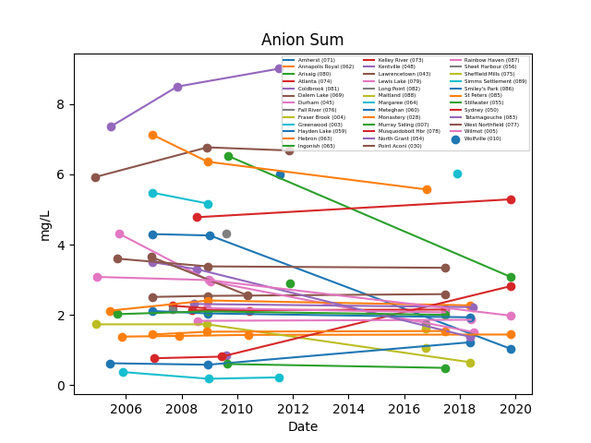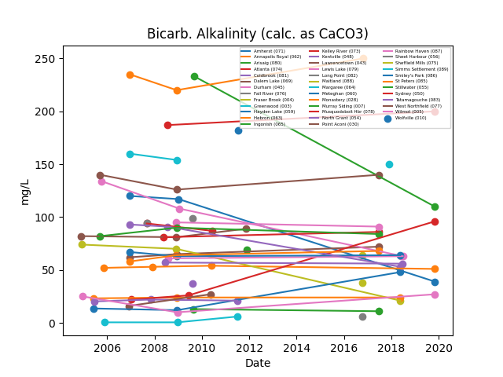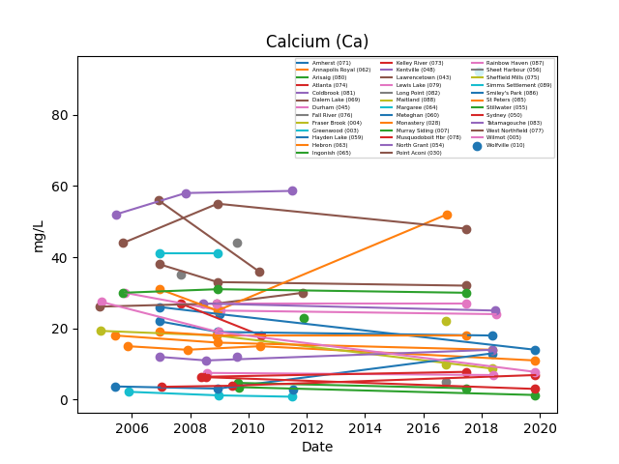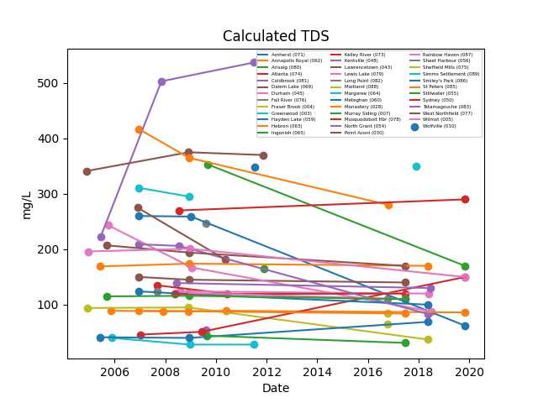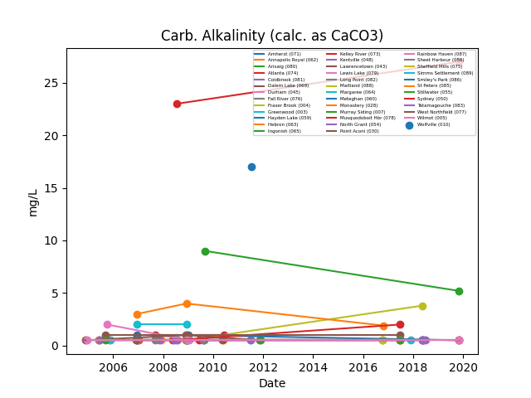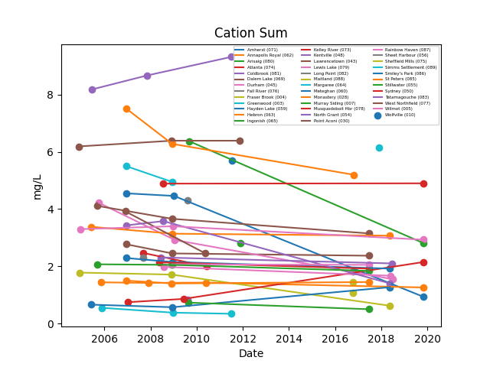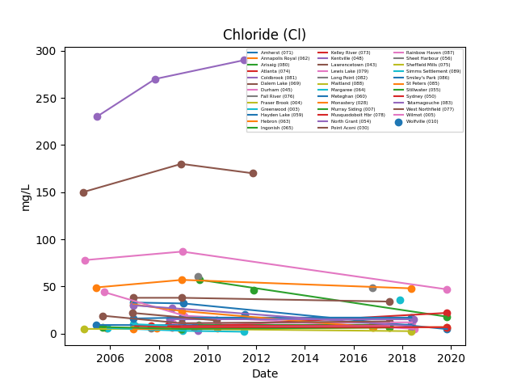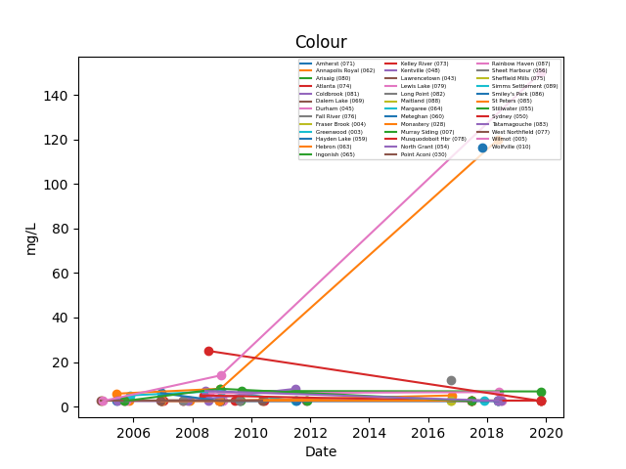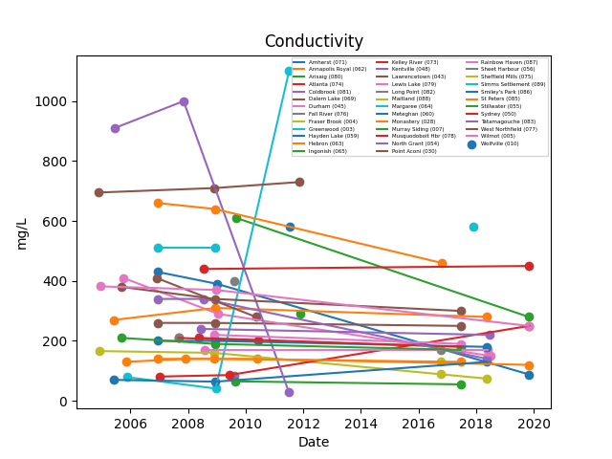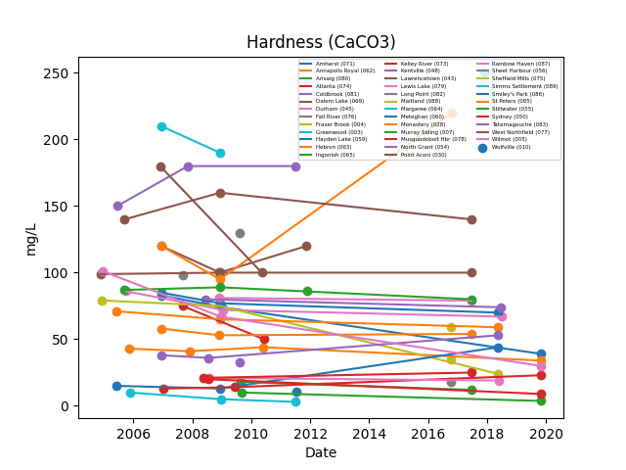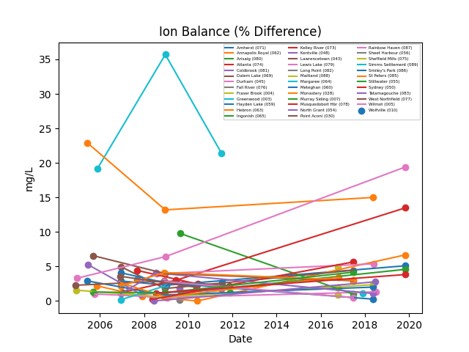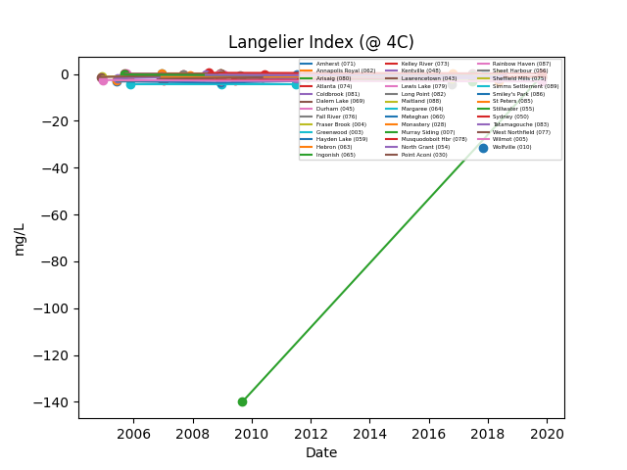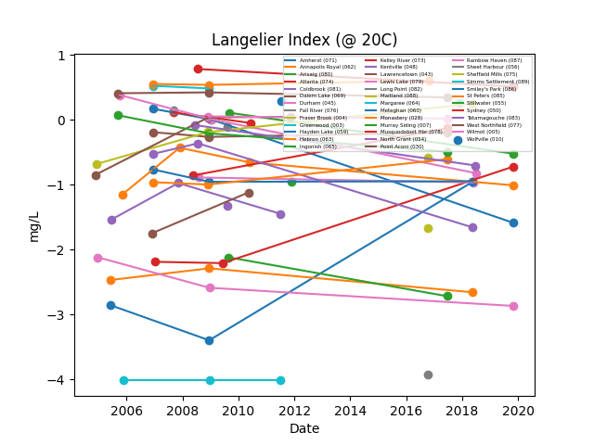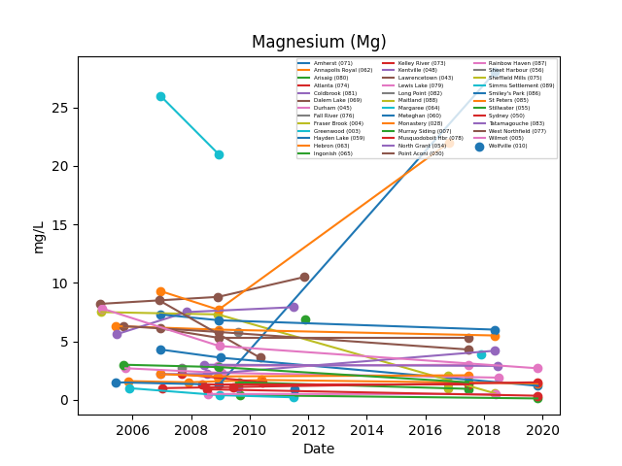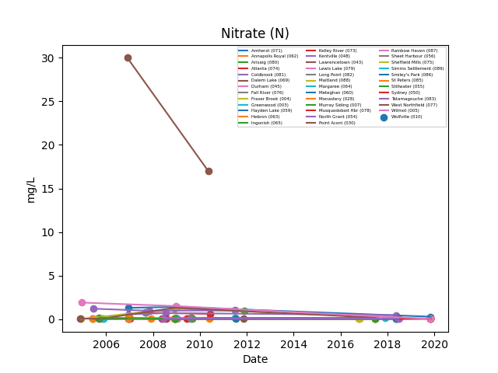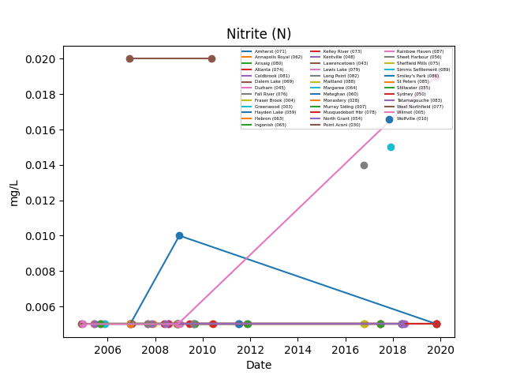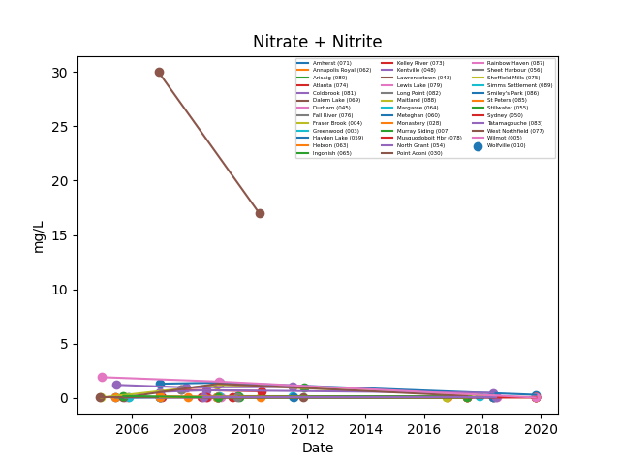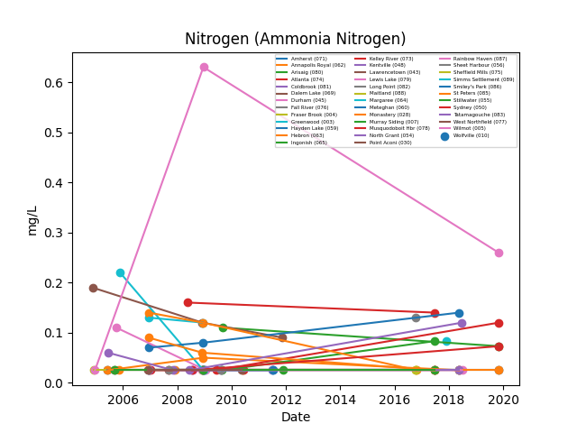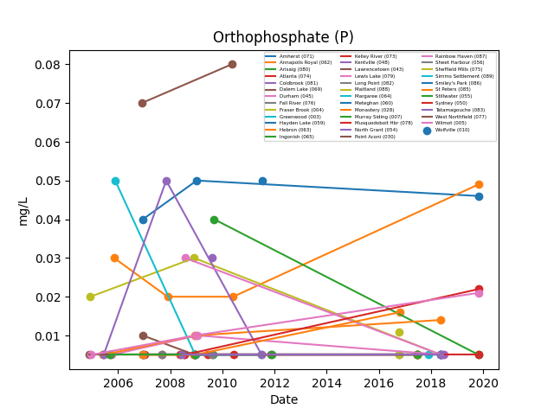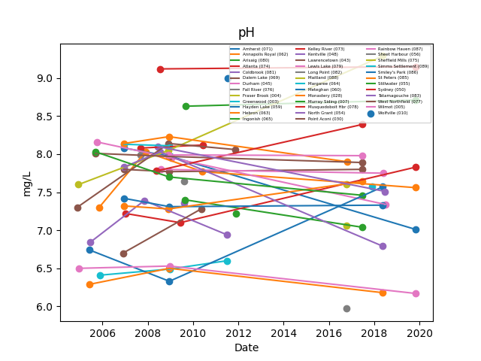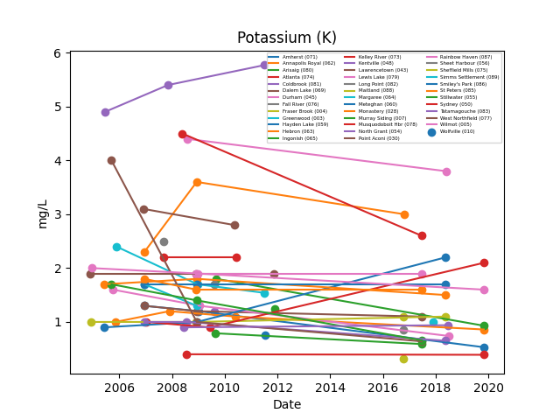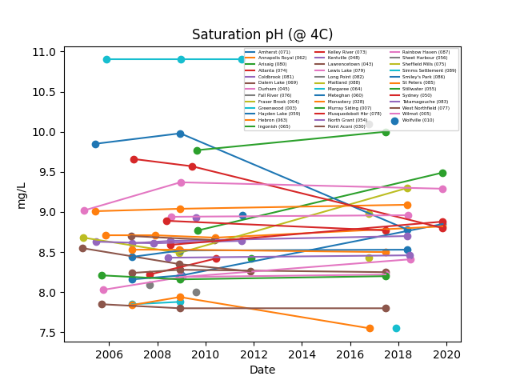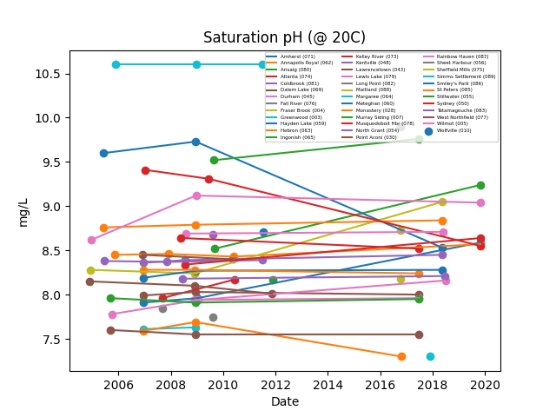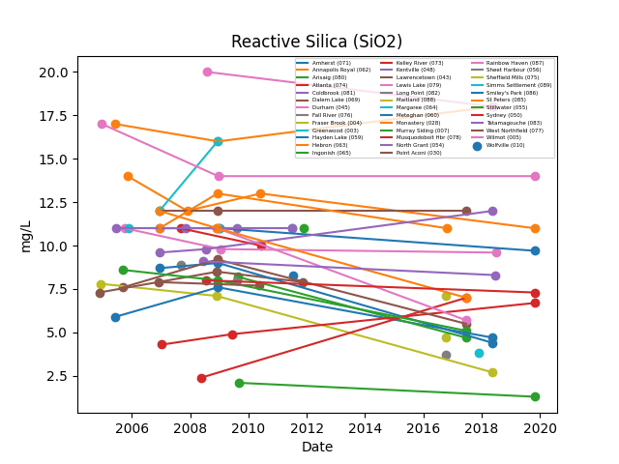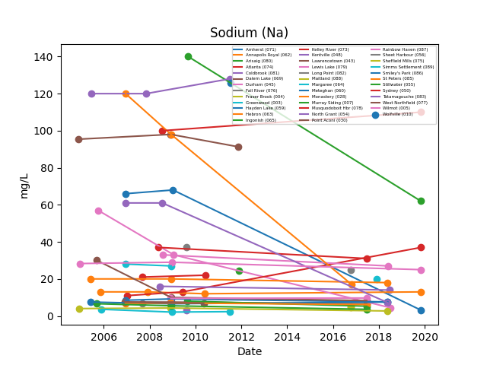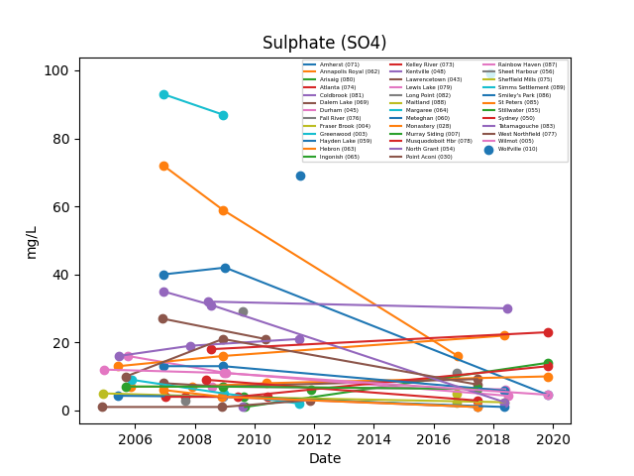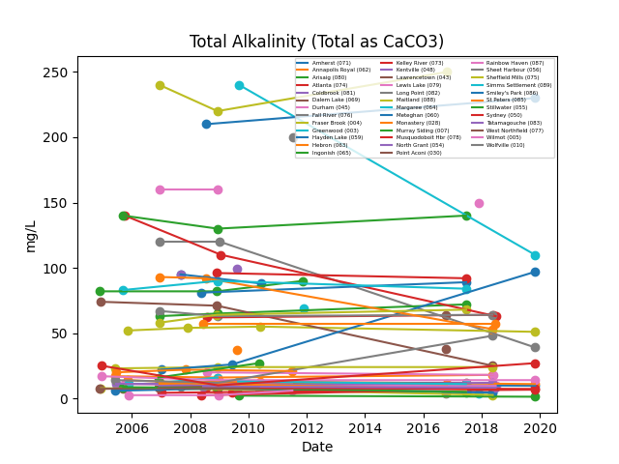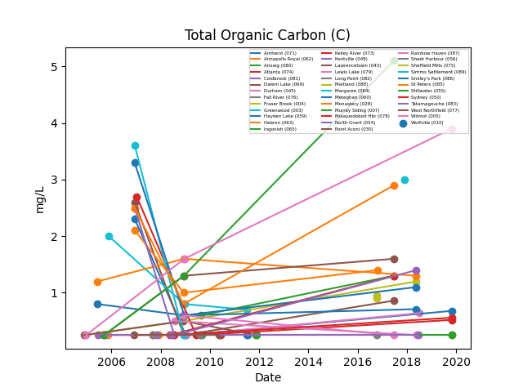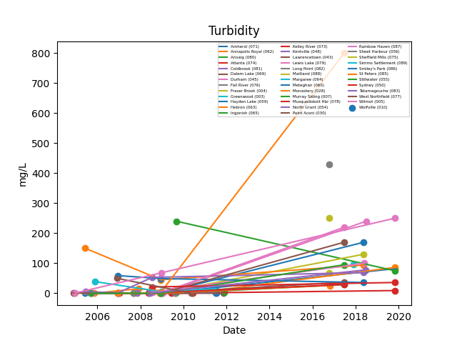

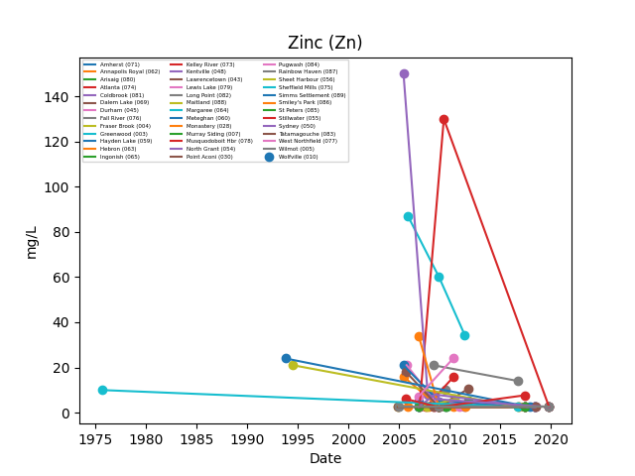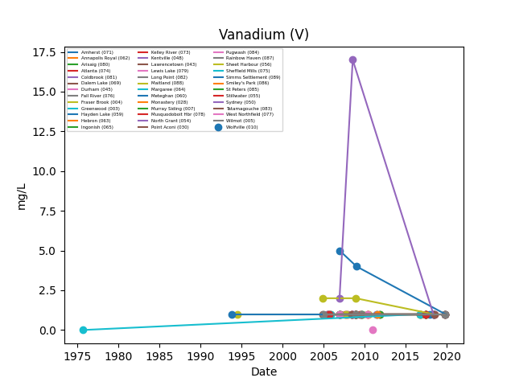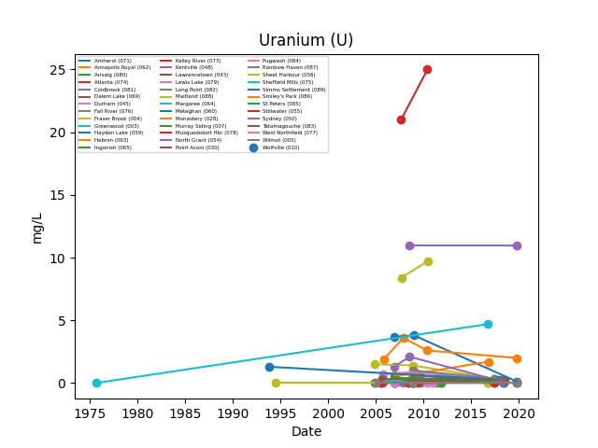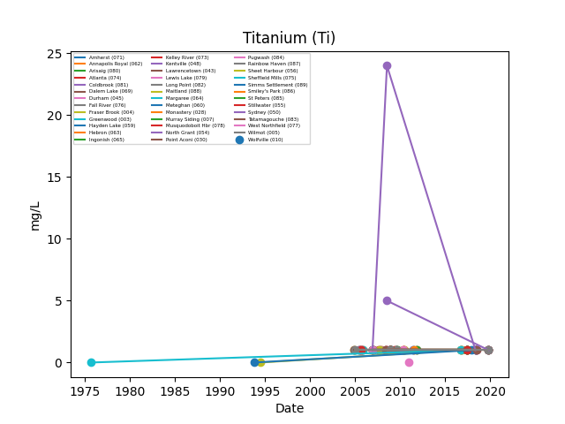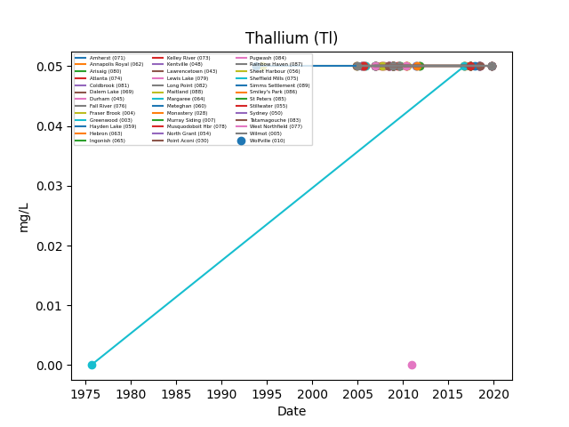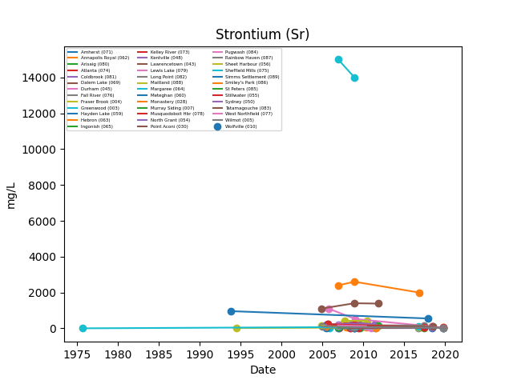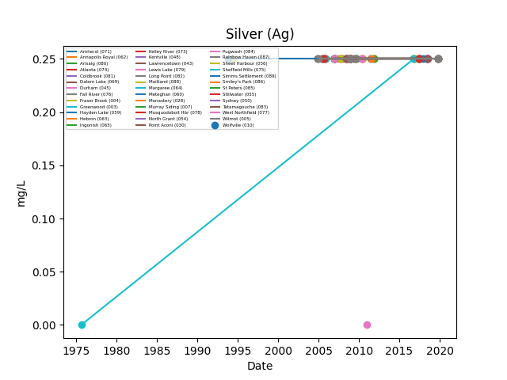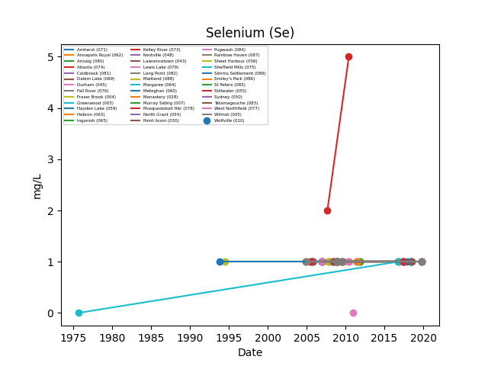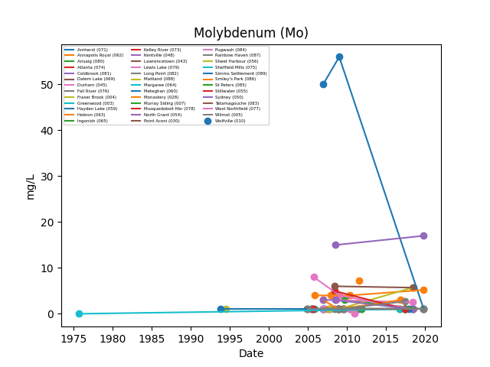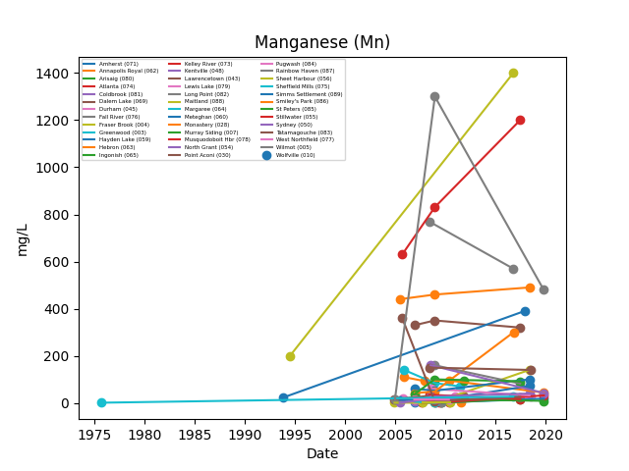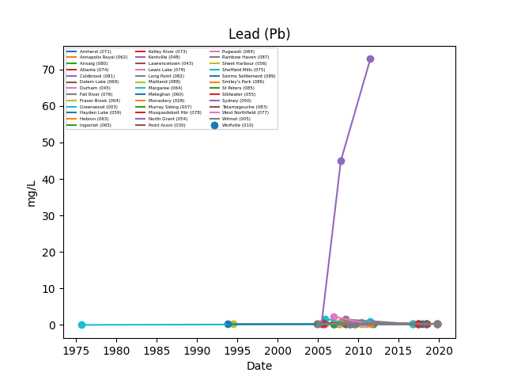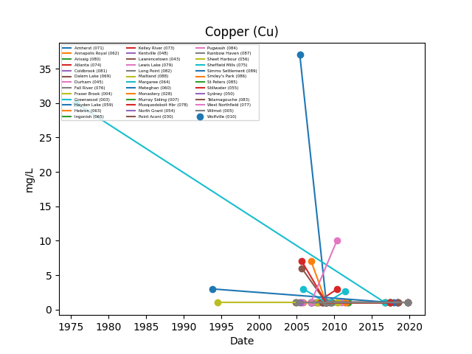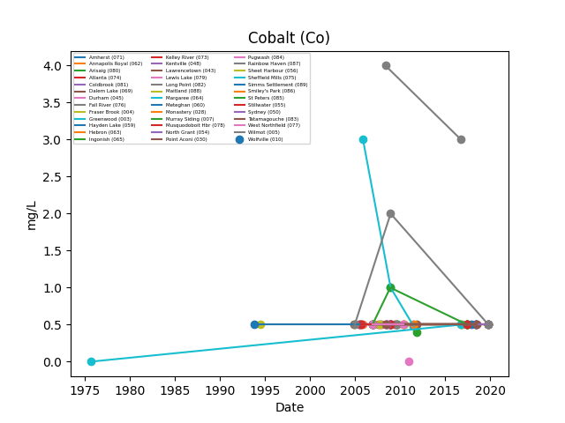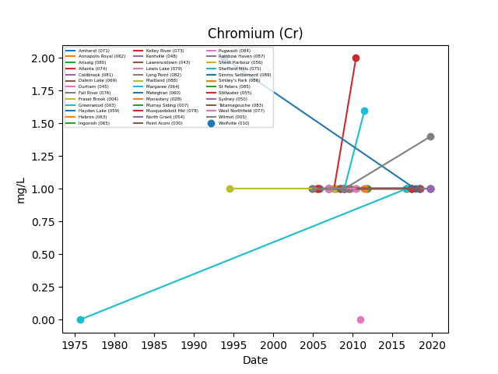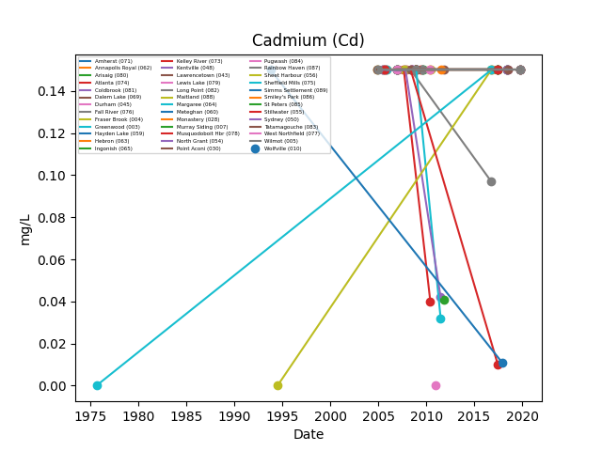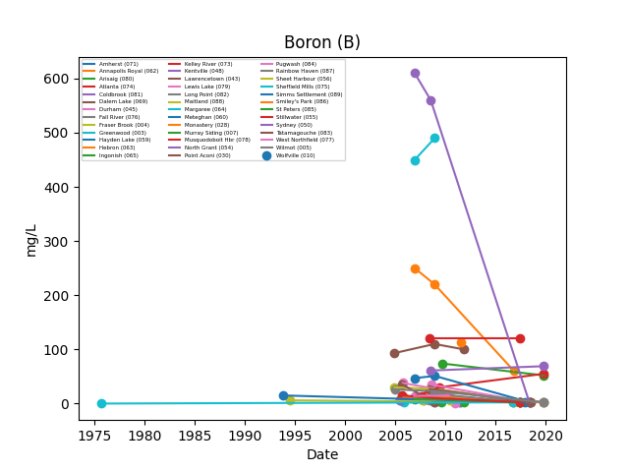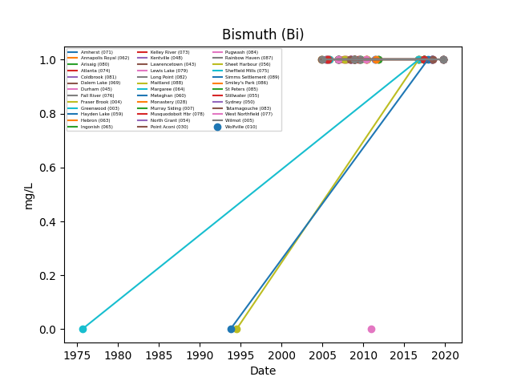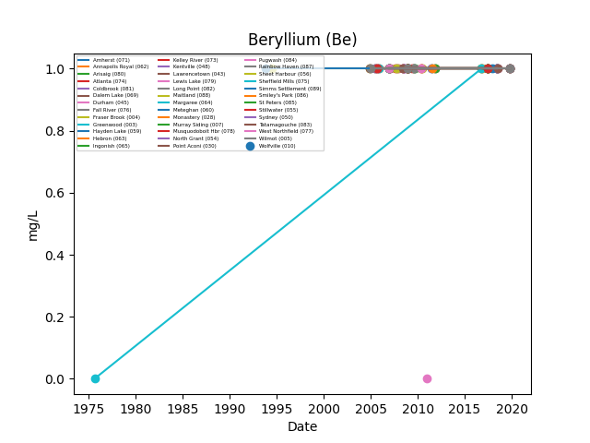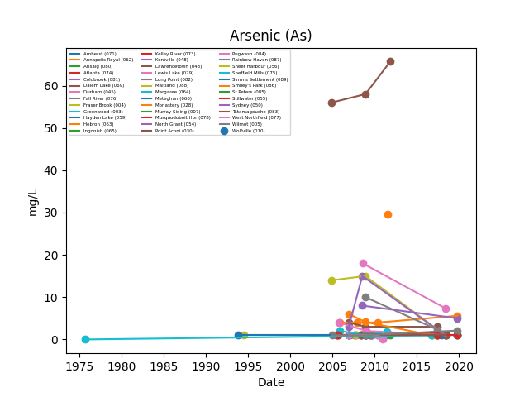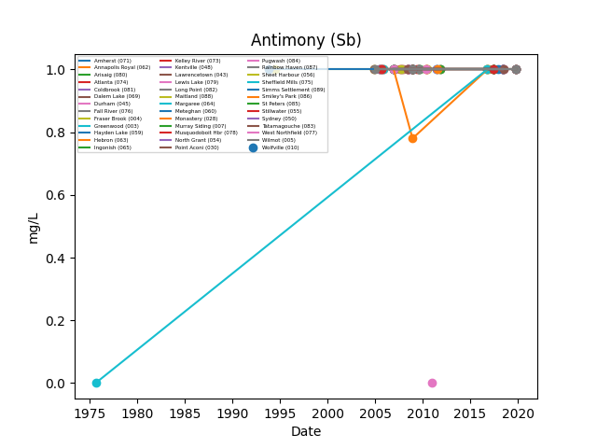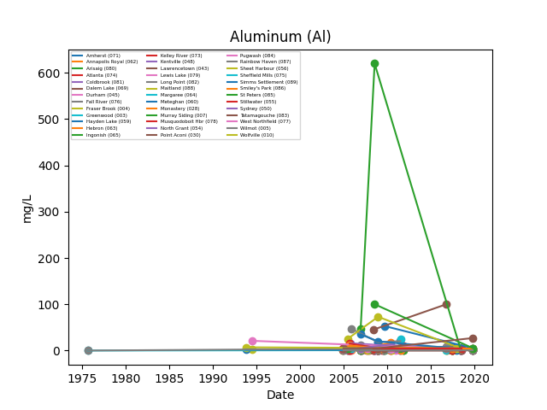

As specified earlier, since few of the areas have no readings in certain dates, those corresponding plots are shorter

X Correlation matrix of all components
The next study was calculating the correlation matrix of the data. I merged all the data together and made a correlation matrix as shown below.

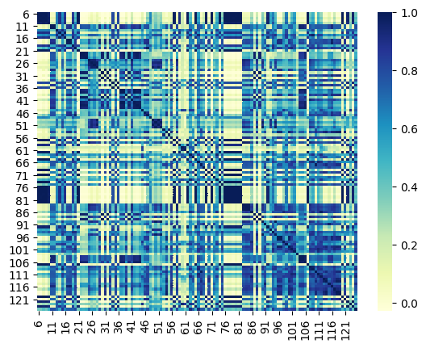

From the matrix it is seen that some values are correlating with each other. This is likely due to geology.
I will further study on the individual components and the specific correlation as III in the next report.

Indication of saltwater intrusion
The saltwater intrusion can be estimated by analyzing various water quality parameters such as conductivity and and total dissolved solids (TDS) in the Ill. In general, saltwater intrusion occurs when saline water infiltrates freshwater aquifers and Ills, leading to a decrease in water quality and potentially limiting the availability of fresh water resources.
As a preliminary test, I have taken some of the components that can indicate salt such as Sodium, Potassium and Magnesium and plotted those quantities against the main metals (Arsenic (As), Aluminum (Al), Antimony (Sb), Barium (Ba), Cobalt (Co), Lead (Pb), and Strontium (Sr)). The plot is shown as below.
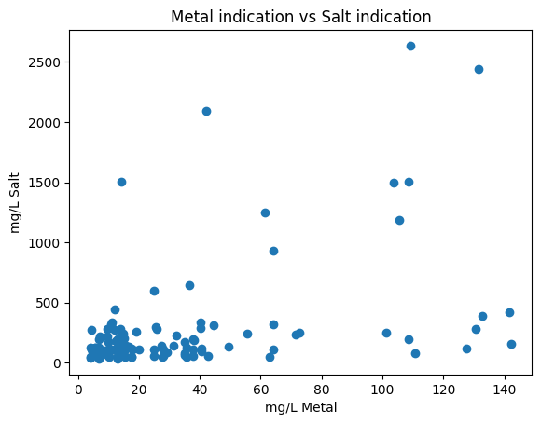
The plot shows that the metal values are mostly loIr when the salt indicator is loIr. This is likely due to the oxidative potential of salts, distance to the coast and bedrock geology

Second study
I have managed to get a large amount of data from a government Ibsite (https://catalogue.data.gov.bc.ca/dataset/aquifer-vulnerability-to-sea-water-intrusion) and started some work on that data. The size of that data is very large (~8GB csv file with another 700MB subfile). The file stores the county locations with times ranging from 1970s till 2021.

Exploration Analysis of data
Analysing the “MONITORING_LOCATION” from the CSV file, there are 2810 locations recorded from the British Columbia section. In order to extract the separate data of each location I used the following code:
dataprocessed = pd.DataFrame()
i = 1
for location in locations[:10]:
print(i, location)
i += 1
subset = datanew.loc[datanew['MONITORING_LOCATION'] == location]
tempdf = pd.DataFrame()
tempdf['MONITORING_LOCATION'] = [location]
tempdf['LATITUDE'] = [subset['LATITUDE'].iloc[0]]
tempdf['LONGITUDE'] = [subset['LONGITUDE'].iloc[0]]
tempdf['COLLECTION_START'] = [subset['COLLECTION_START'].iloc[0]]

for param in subset['PARAMETER']:
if pd.isna(param):
continue
tempdf[str(param)] = [subset.loc[subset['PARAMETER'] == param, 'RESULT'].iloc[0]]
dataprocessed = pd.concat([dataprocessed, tempdf], ignore_index=True)

This is a portion of the data sample from ‘dataprocessed’
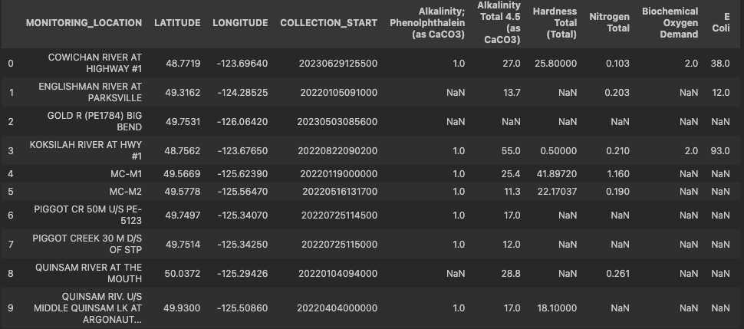

Visualizing the data via map plots
In order to visualize the data and the effect of the parameters of the data in each location, I have taken SHP files of the area and then arranging a plot on the graph whilst matching the latitude and longitude of the locations in the map.
Currently I am working to merge the location data with the map data of BC.
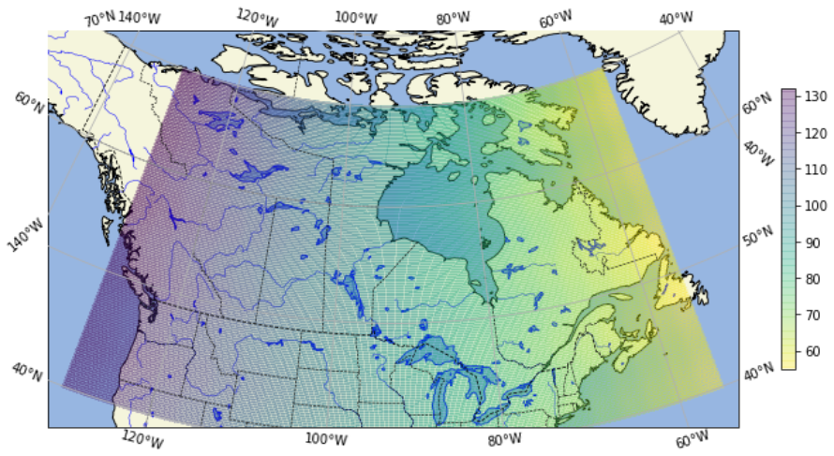
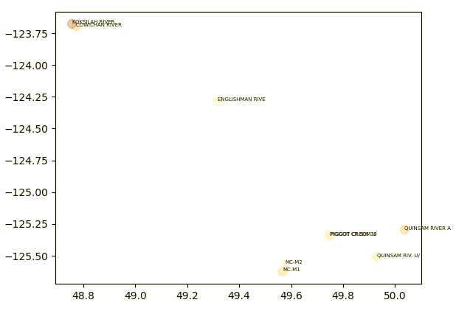

Further studies planned
The one of the key issues is the lack of data available from Nova Scotia. So I am seeking larger data sets in B.C. and Australia.
I can perform further studies to validate this hypothesis by clustering the Ills based on the location to get a general composition of the metals and components. With those value I can perform tests such as the ANOVA test to see if the Ills are indeed different based on its geographic location with respect to the coast and other factors such as the lithography and aquifer type.
I also want to see if I can correlate groundwater metals data with precipitation, evaporation, soil temperature and temperature.

